Visualising Trip Durations by Rail   
throughout Europe and France with Tempograpic Maps

Charles GAYDON  
 Université de Lyon

Paul PESEUX   
 Université de Lyon

Loïc ROBERGEON  
 Université de Lyon

Abstract

**Trip durations between two geographical points are rarely proportional to the geographic distances one can see on a standard map. As a result, the visualisation of temporal relationships between objects on a map could be invaluable, to e.g. a tourist wanting to visit another city without travelling too long. We hereby propose some designs suggestions for such a map. We conceive two different tempographic maps, of France and Europe respectively, in which distances between main cities can be distorted to make visible the train trip durations between them. The design shall provide the user with information about the cities he is interested in as well. This kind of work has, to our best knowledge, never be done on a dynamic set, nor on a full European map.**

**Keywords**: Tempographic maps, time-space maps, DataViz, rail network.

# Introduction

Since the first so-called “bullet train” in 1964 in Japan, high-speed trains spread throughout the world and deeply changed the conception we have of space. Destinations that were virtually inaccessible previously stand now reachable in a couple of hours. The world, and within it Europe, is said to be “shrinking” as trip durations shorten. But it is common knowledge that trip times are not always, if not never, proportional to the distance travelled. This is due to an uneven rail network in term of speed and frequency, and to various geographical constraints (e.g. a lake to circumvent). As a result, one can observe that it is hard with common static maps to really evaluate how fast a city can be accessed from another one. A map where the time component of train trips is visualised could thus be invaluable. A use case could be: a Canadian globe-trotter wants to establish for one year in a major European capital city, and search for a place from which many other important cities could be accessible easily.

# Related Works

The concept of visualising time on a two-dimensional map is quite old, but most works that can be found deal with the representation of event that occurs through time (e.g. [1] ), instead of the representation of time relationships between objects with a geometric position.

The term “tempographic map” appears to have been coined by van Schaick , an urbanism teacher [2]. A tempographic map consists of the distortion of geographic distances on a map to fit a notion of time.

## Europe: to focus or not to focus?

Spiekermann and Wegener have in the 90’ published a few work papers on this idea, for the German Institute for Country Planning [3]. They pursued the same aim as ours: to visualise the shrinking of space induced by high-speed rail lines. They followed two sub-goals. First, proposing different visualisations of the “time context” of a city. This translate into different areas and circles around one reference city. Marks and colours can then translate a one-to-many temporal relationship. The second is more broadly to give to the reader a snapshot of temporal relationships between any two points of a map. Here, they use an algorithm that iteratively rearrange a grid of points on a map in order to make distances fit best the trail trip durations. They use interpolation methods to distort every point of the map, even the ones for which no temporal relationship is available. This can be seen as a case of Multidimensional Scaling (MDS). In MDS, a distance matrix is used to position points on a 2D plan. Here, the distance matrix corresponds to trip durations between objects, and distances to missing points on the maps (e.g. a point that is not a city) were inferred by interpolation. The result is quite interesting, but is only an approximation. Furthermore, the readability is not optimal.

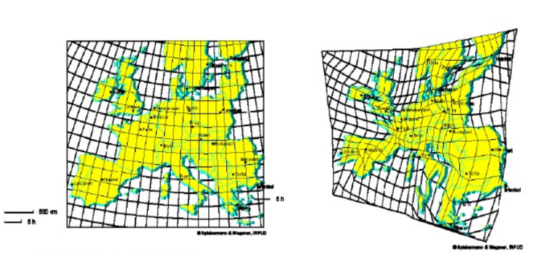

1. A tempographic map as conceived by [3]

## France: everything is relative

Some maps of trip durations in France can be found online [4][5]. The French high-speed rail network is shaped like a star, whose centre is Paris. Thus, the maps are often centred around Paris, and only the temporal relationship between Paris and another city can be visualised. This represents a point of progress, as to our best knowledge there is no existing map that dynamically enables the user to set another city as a reference.

# DESIGN SUGGESTION

By looking to previous works, we validated that a map in which trip durations by train from any city to any other city has never been done before and could be really invaluable.

## Broad view

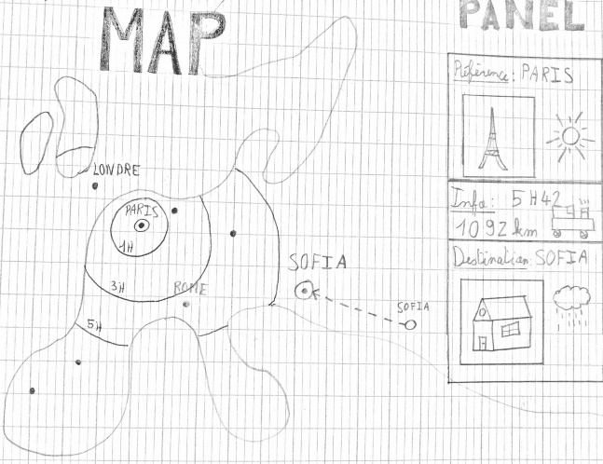The application consists of two maps, each displaying a right panel as an interactive legend.

Figure 2: An overview of the European tempographic map

## The maps: France and Europe

The user has a choice between a map of Europe and a map of France. Prior to any action of the user are displayed standard geographic maps, showing main cities and the country borders. The selection of one city by a mouse click (suggested in the panel) makes it the “reference city” (called ***R***). This will move the other cities on a radial axis whose centre is ***R***, closer or further depending on the trip duration to go there. Simultaneously, the background map of France (not the case for Europe) will be distorted around ***R***. ***R*** will be encircled by isochrone lines corresponding to hours of train needed to reach them. Hence, it will be easy to visualise the relative duration to access a city from ***R*** as well as the absolute time needed to reach it. This map will be displayed on the left and centre of our screen. On the border right of our screen will be an information panel.

## The lateral panel: a trip planner?

Once ***R*** is selected, user can focus on another city considered as its destination ***D***. The lateral panel is then a description of a potential train travel from ***R*** to ***D***. It is separated in three parts, namely the description of our reference city ***R***, information on this trip, and the description of our destination city ***D***. In the descriptions of a city can be found things like its number of inhabitant, weather, possible activities, a picture, etc. In the travel details part can be fond the exact time to reach this destination, how many kilometres far it is, etc. This should enable the user travelling to a particular city to get some insight into the local trips perspective that this city offers.

## The data

We use Google Matrix Distance API to get trip durations by rail. If some data are missing, we plan to use a shortest path algorithm to give an approximation of the time needed to access a city.

# Conclusion

References

[1] B. Bach, P. Dragicevic, D. Archambault, C. Hurter, and S. Carpendale, ‘A Review of Temporal Data Visualizations Based on Space-Time Cube Operations’, 2014.

[2] J. van Schaick, ‘Mapping Time Spaces - the basics’, *Slideshare*, 2009. [Online]. Available: https://www.slideshare.net/jeroenvanschaick/schaickurbanbodymappingtimespace02.

[3] K. Spiekermann and M. Wegener, ‘New Time-Space Maps for Europe.’, 132, 1996.

[4] A.-A. Durand and G. Dagorn, ‘Comment le TGV a rétréci la France’, *Le Monde*, 2017. [Online]. Available: http://www.lemonde.fr/les-decodeurs/visuel/2017/07/01/comment-le-tgv-a-retreci-la-france_5154203_4355770.html.

[5] P. Gambette, ‘La France en train depuis Paris’, 2014. [Online]. Available: http://philippe.gambette.free.fr/Train/.